Download MySQL installer

<https://dev.mysql.com/downloads/mysql/>

After you finish downloading. You might get this pop up. If you do not have VS 2019, you’ll need to download it from here

<https://learn.microsoft.com/en-us/cpp/windows/latest-supported-vc-redist?view=msvc-170#visual-studio-2015-2017-2019-and-2022>

Select x64

Once downloaded and installed reboot and come back and install MySQL.

Should work now

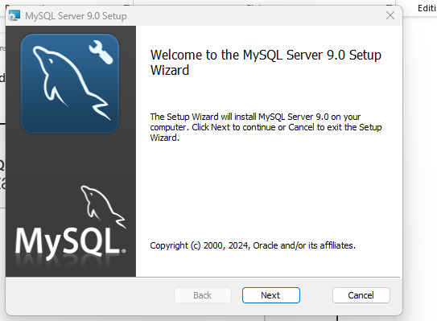

Choose Typical

Now hit Finish

You’ll get a Wizard like this, hit Next

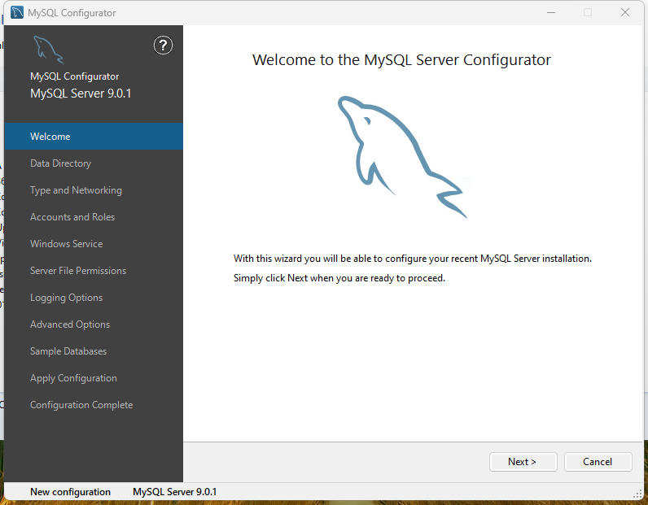

Now, enter a root password

You can change the Windows Service Name If you want to. I’m naming it Testing.

After successful hit next

Then Finish

Now, next you’ll want to download MySQL Workbench here

<https://dev.mysql.com/downloads/workbench/>

After downloading start the installation process

After installation, hit Finish

This window will pop up, you might get a Local Instance if not that’s fine.

Instead of using the local Instance, let’s create our own.

Go to MYSQL Workbench, click on the plus symbol

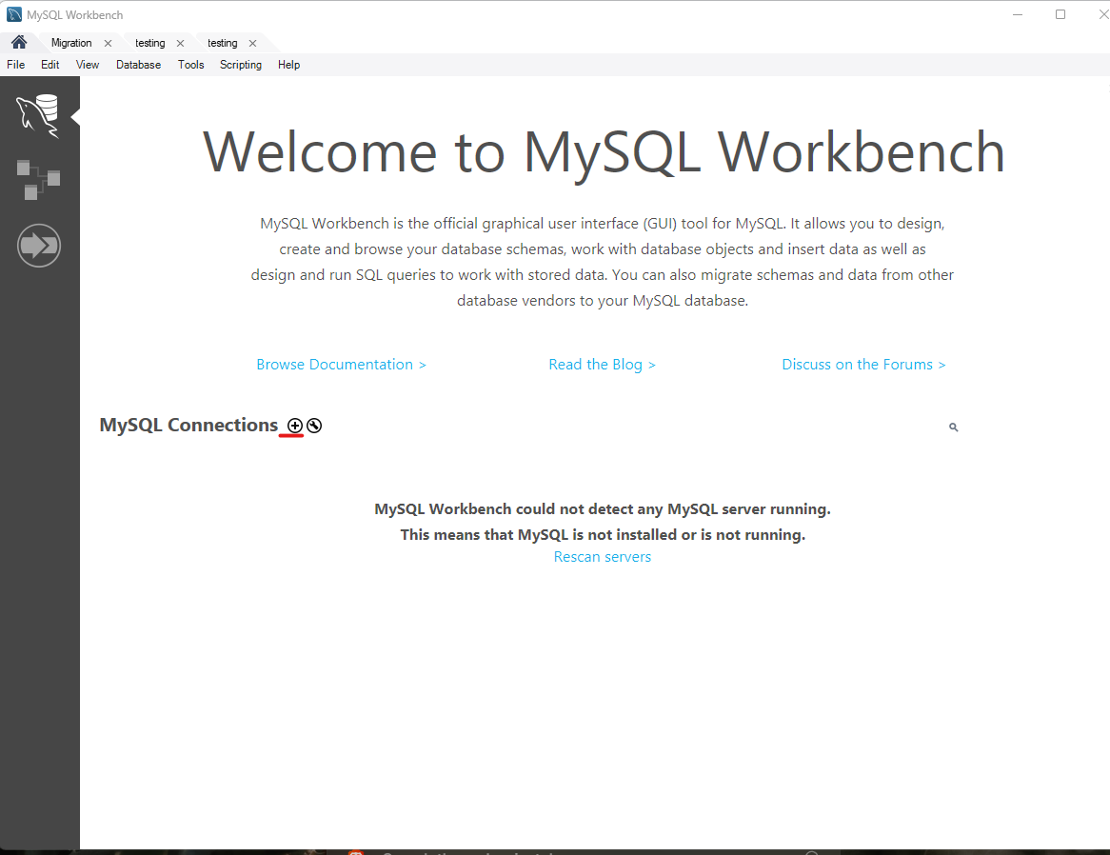

You can enter a name I named it testing

Click on

Enter your root password

You might get this warning just continue Anyway.

Next, Create Schema, enter a name for it, hit apply, apply, then finish.

Now testing should be in the Schemas folder if not refresh

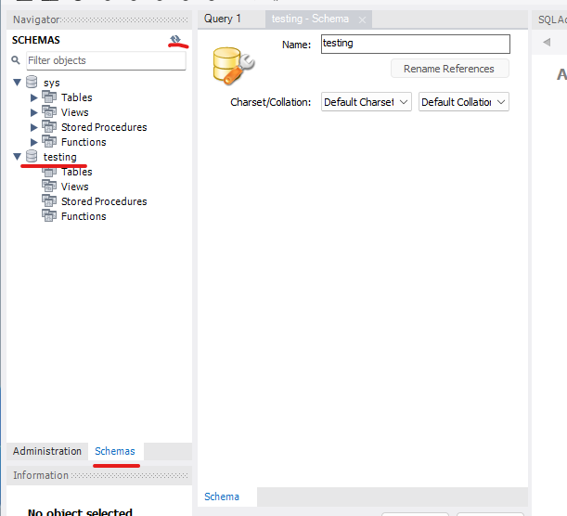

Double click on testing, a bold black means you’re working on it

Rick click on tables, Create table

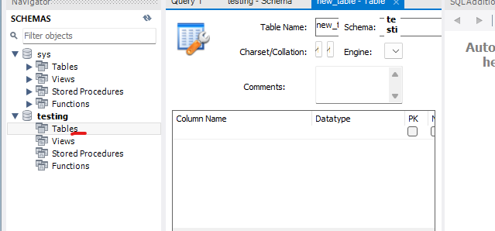

Enter a table name, click on the PK, edit, create, hit apply

You can test if it’s working. If you get null | null | null it’s working.

You can delete the local instance

Now for BookNow to connect to your local MySQL server.

You’ll have to change the URL, Username, and password to your own.

In order to do that right click on your MySQL Connection

Copy the JDBC Connection String to Clipboard

Your copied JDBC Connection will look like this

jdbc:mysql://127.0.0.1:3306/?user=root

in the highlighted yellow remove and enter the name of the JDBC Connection which is testing

jdbc:mysql://127.0.0.1:3306/testing

copy that and paste it in the DATABASE_URL

For the username set it to “root”

Password set it to your root password.

To test if BookNow connects to your local MySQL server

Run the application, and hit create new account

I’m going to create an account. The username is my name: Jimmie and the password is my last name: Xiong and hit create. Capital and lower doesn’t matter they are treated the same.

After hitting create account you’ll see a pop up that display Account created successfully.

Hit the log in button to go back

Enter your username and password, and if it works you should see a pop up that display your username.

To verify that your account was successfully created in your MySQL database. Go back and test the query, and if you see the account you created. Means you’re good!!!

